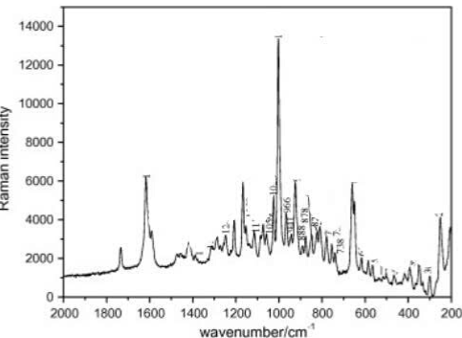

Figure 1: <https://doi.org/10.1016/j.molstruc.2011.01.053>

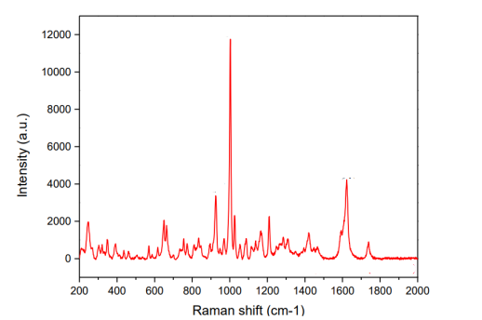

Figure 2: <https://doi.org/10.4028/www.scientific.net/KEM.853.102>

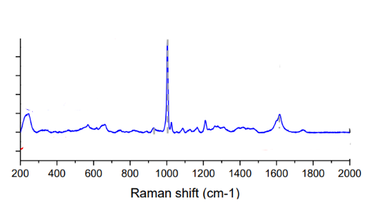

Figure 3: <https://doi.org/10.4028/www.scientific.net/KEM.853.102>

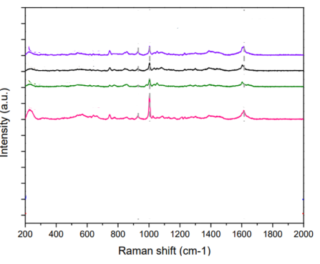

Figure 4: <https://doi.org/10.4028/www.scientific.net/KEM.853.102>

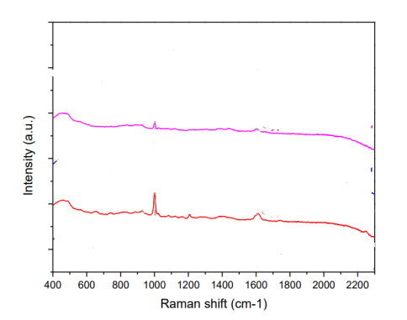

Figure 5: <https://doi.org/10.4028/www.scientific.net/KEM.853.102>

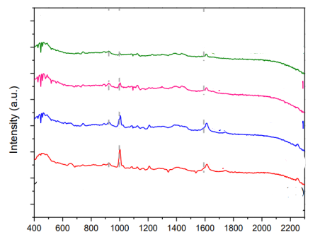

Figure 6: <https://doi.org/10.4028/www.scientific.net/KEM.853.102>

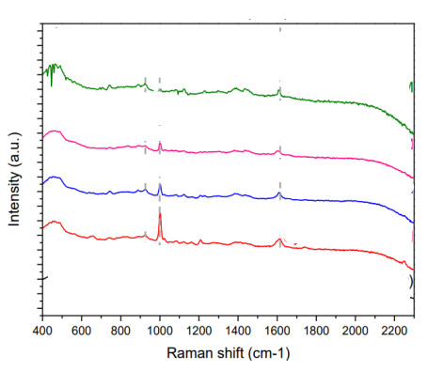

Figure 7: <https://doi.org/10.4028/www.scientific.net/KEM.853.102>

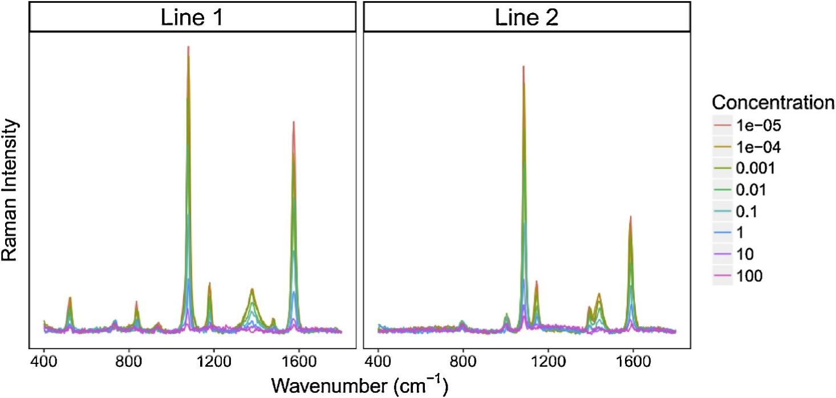

Figure 8: <https://doi.org/10.1016/j.snb.2018.11.112>

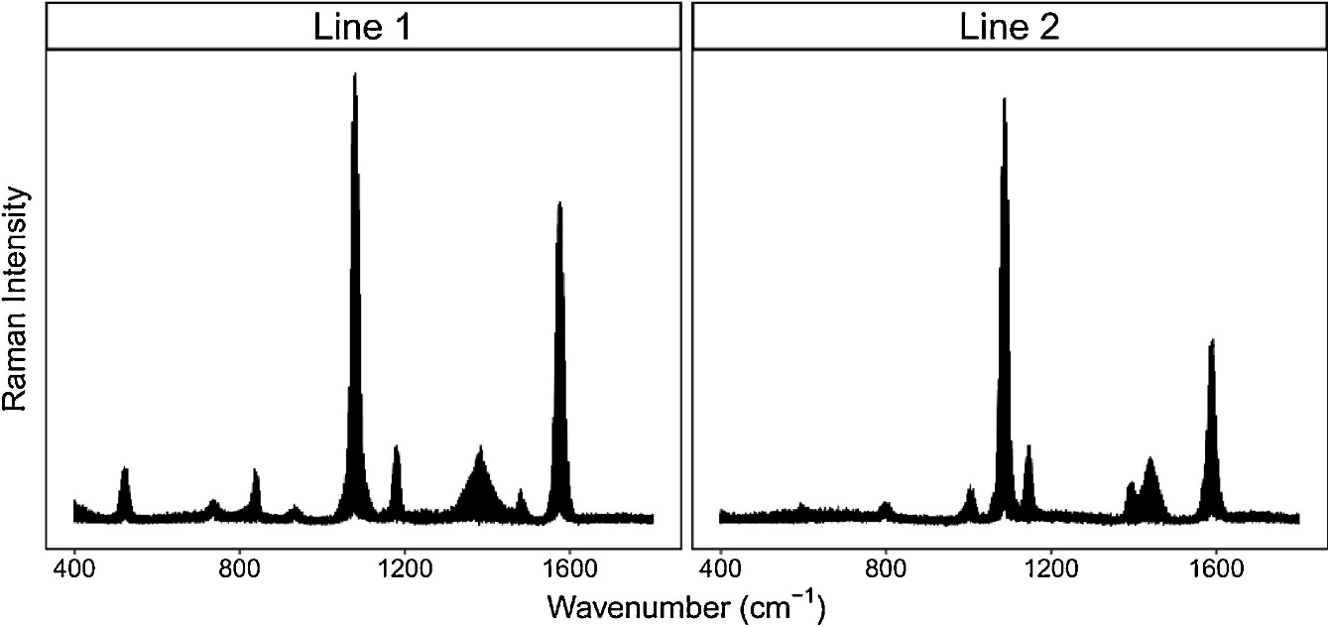

Figure 9: <https://doi.org/10.1016/j.snb.2018.11.112>

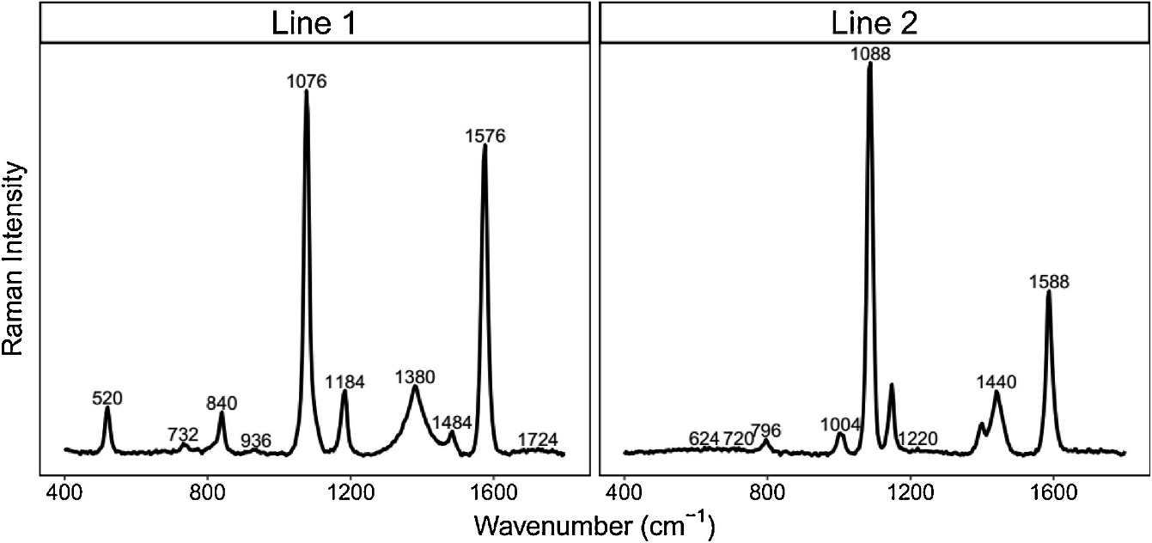

Figure 10: <https://doi.org/10.1016/j.snb.2018.11.112>

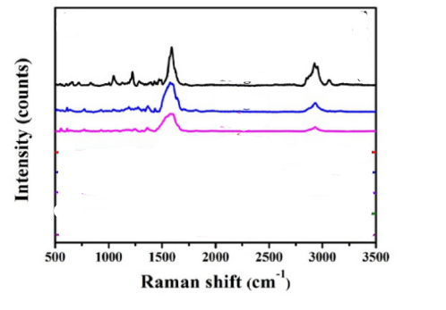

Figure 11: <https://doi.org/10.1364/OE.26.022168>

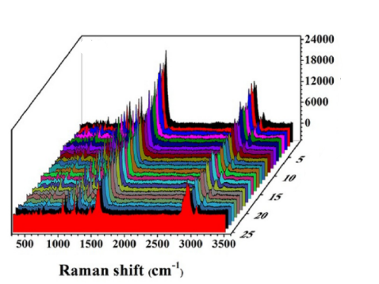

Figure 12: <https://doi.org/10.1364/OE.26.022168>

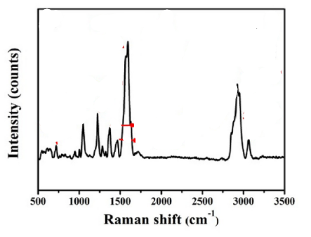

Figure 13: <https://doi.org/10.1364/OE.26.022168>

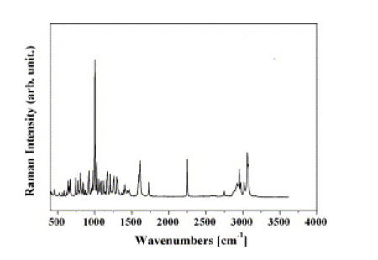

Figure 14: <https://doi.org/10.1016/j.saa.2006.06.017>

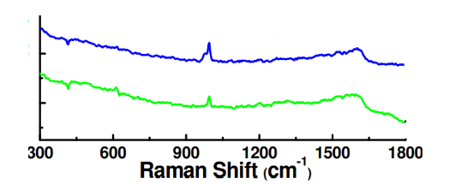

Figure 15: <https://doi.org/10.4028/www.scientific.net/AMR.979.259>

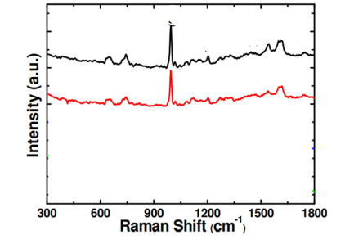

Figure 16: <https://doi.org/10.4028/www.scientific.net/AMR.979.259>

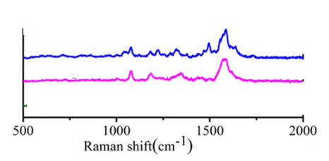

Figure 17: <https://doi.org/10.1038/s41598-018-25228-8>

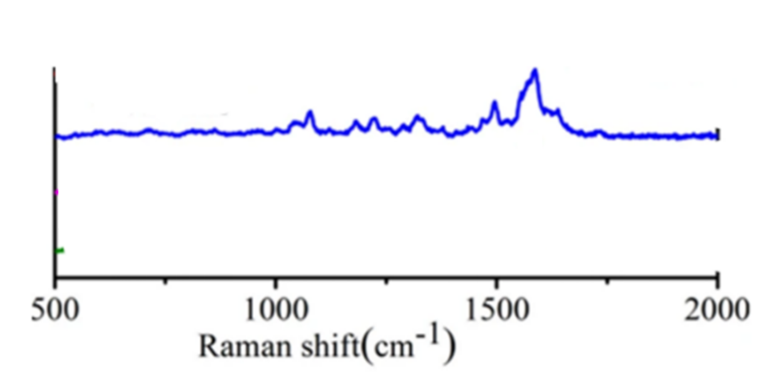

Figure 18: https://doi.org/10.1038/s41598-018-25228-8

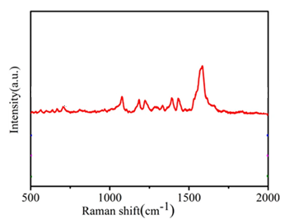

Figure 19: <https://doi.org/10.1038/s41598-018-25228-8>

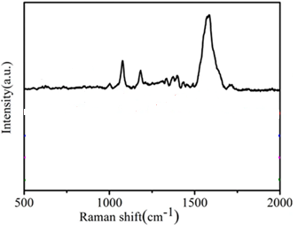

Figure 20: <https://doi.org/10.1038/s41598-018-25228-8>

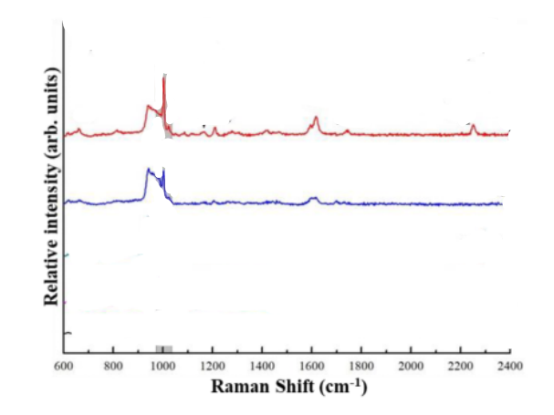

Figure 21: <https://doi.org/10.3390/coatings10080751>

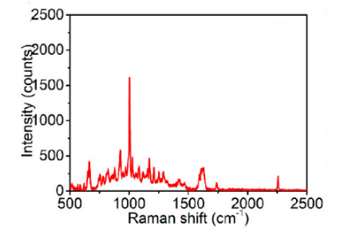

Figure 22: <https://doi.org/10.1021/acssuschemeng.2c03220>

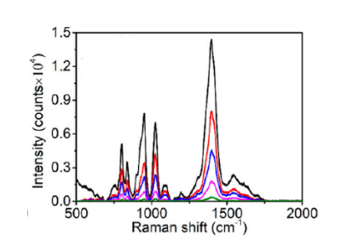

Figure 23: <https://doi.org/10.1021/acssuschemeng.2c03220>

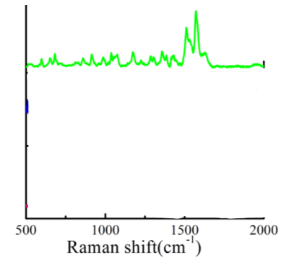

Figure 24: <https://doi.org/10.3390/nano8050289>

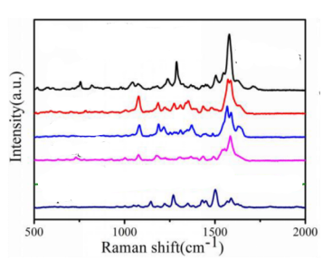

Figure 25: <https://doi.org/10.3390/nano8050289>

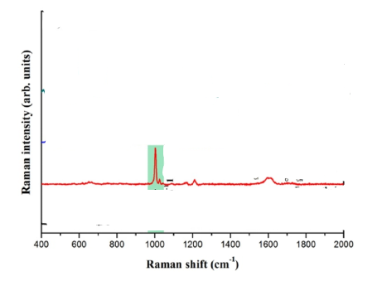

Figure 26: <https://doi.org/10.1016/j.jtice.2017.03.022>

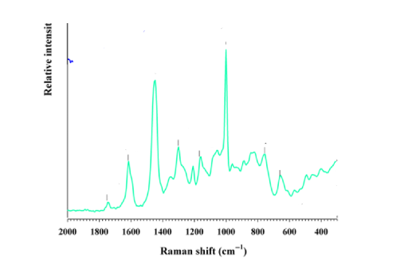

Figure 27: <https://doi.org/10.3390/foods14142543>

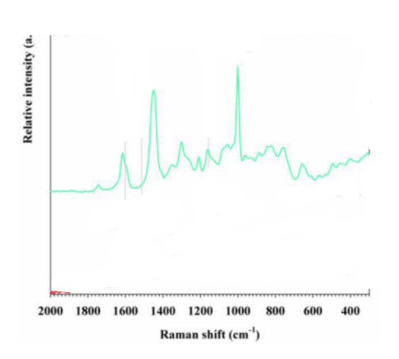

Figure 28: <https://doi.org/10.3390/foods14142543>

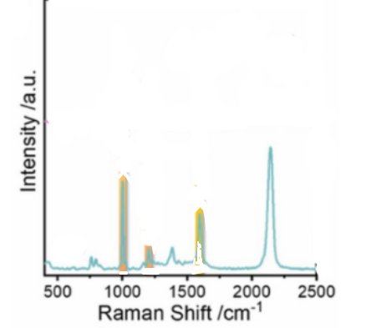

Figure 29: <https://doi.org/10.1016/j.jhazmat.2023.133338>

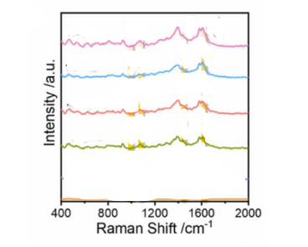

Figure 30: <https://doi.org/10.1016/j.jhazmat.2023.133338>

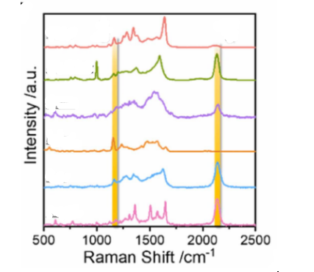

Figure 31: <https://doi.org/10.1016/j.jhazmat.2023.133338>

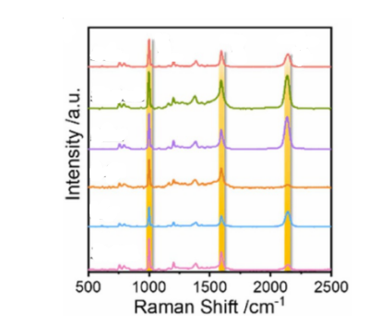

Figure 32: <https://doi.org/10.1016/j.jhazmat.2023.133338>

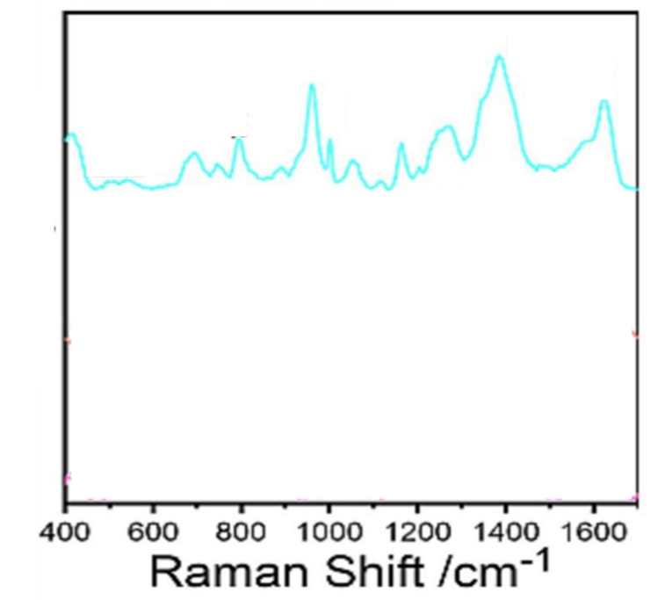

Figure 33: <https://doi.org/10.1016/j.foodchem.2023.138214>

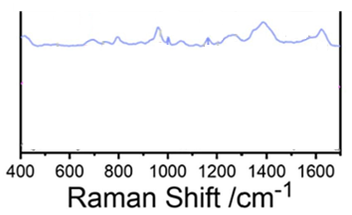

Figure 34: <https://doi.org/10.1016/j.foodchem.2023.138214>

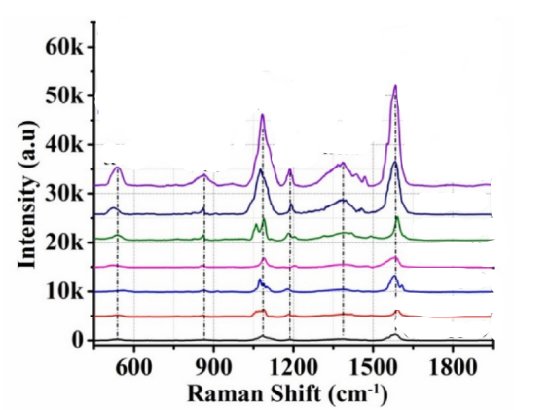

Figure 35: <https://doi.org/10.1016/j.optmat.2022.112196>

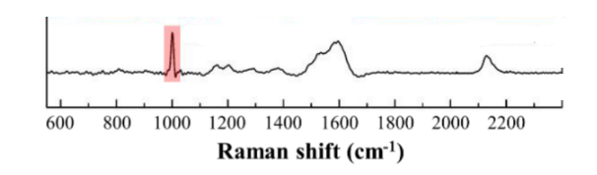

Figure 36: <https://doi.org/10.3390/nano8060402>

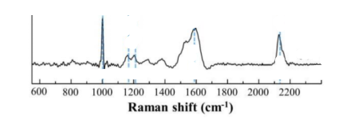

Figure 37: <https://doi.org/10.3390/nano8060402>

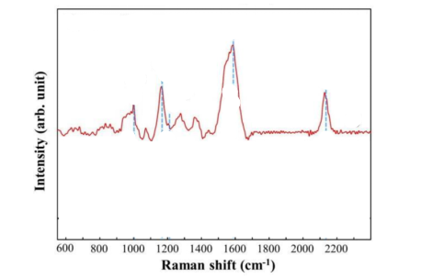

Figure 38: <https://doi.org/10.3390/nano8060402>

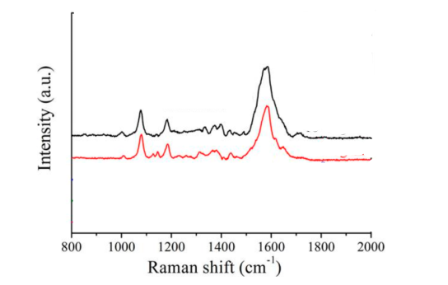

Figure 39: <https://doi.org/10.3390/nano9050672>

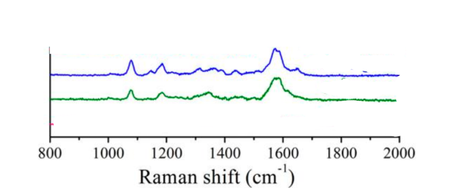

Figure 40: <https://doi.org/10.3390/nano9050672>

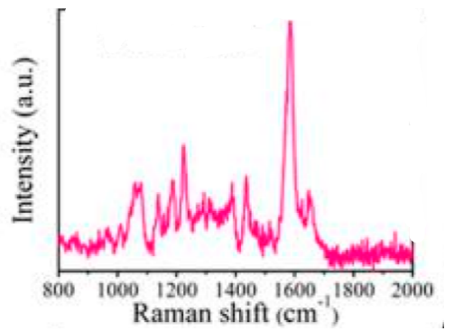

Figure 41: <https://doi.org/10.3390/nano9050672>

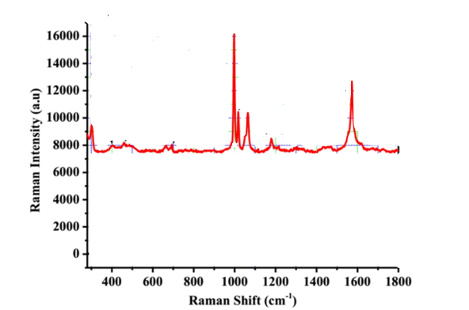

Figure 42: <https://doi.org/10.1038/s41598-019-49077-1>

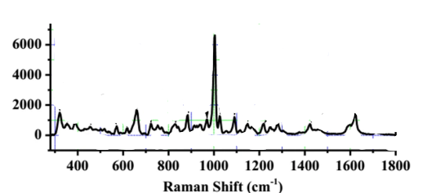

Figure 43: <https://doi.org/10.1038/s41598-019-49077-1>

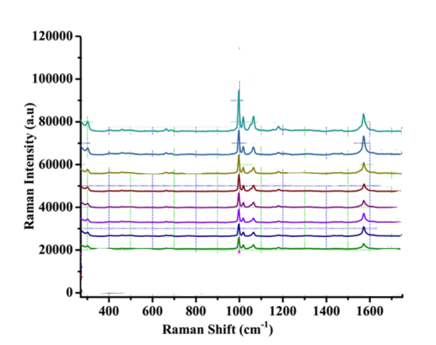

Figure 44: <https://doi.org/10.1038/s41598-019-49077-1>

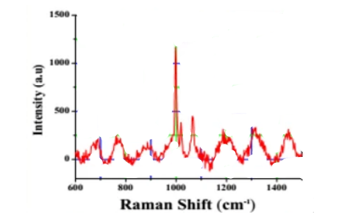

Figure 45: <https://doi.org/10.1038/s41598-019-49077-1>

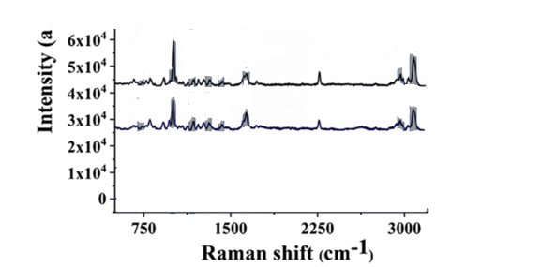

Figure 46: <https://doi.org/10.1007/s00604-020-04558-3>

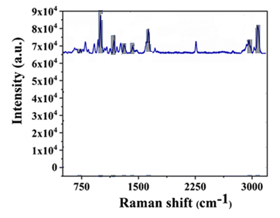

Figure 47: <https://doi.org/10.1007/s00604-020-04558-3>

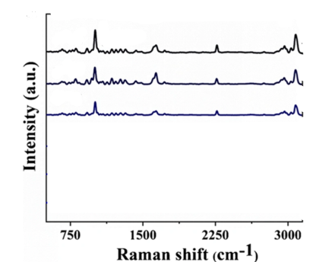

Figure 48: <https://doi.org/10.1007/s00604-020-04558-3>



Figure 49: https://doi.org/10.1007/s00604-020-04558-3

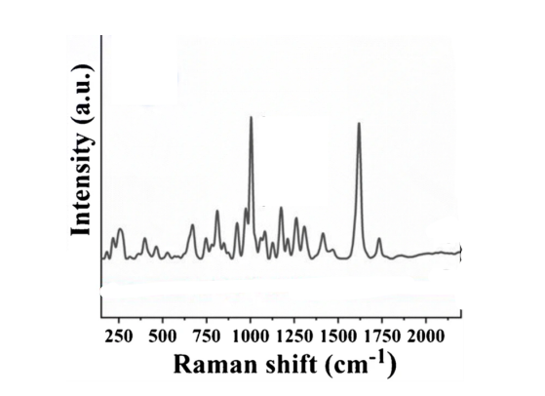0

Figure 50: <https://doi.org/10.1007/s00604-020-04558-3>

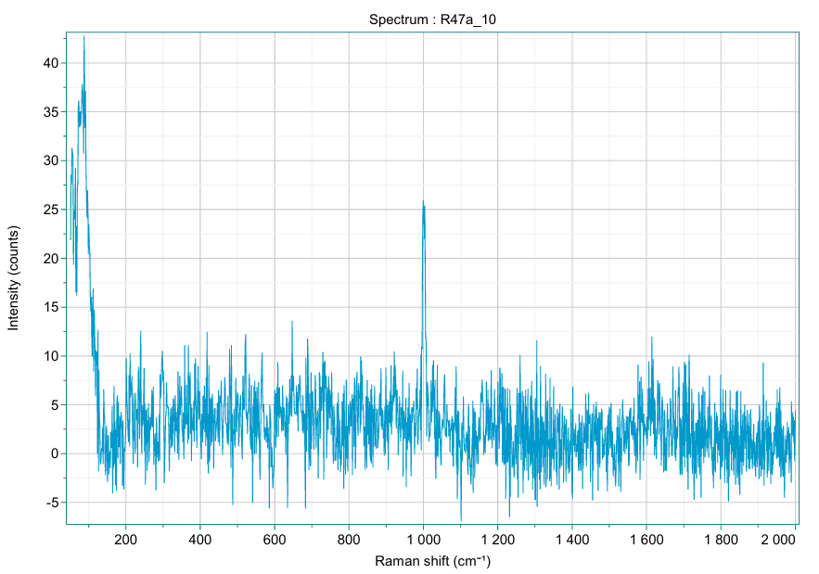

Figure 51

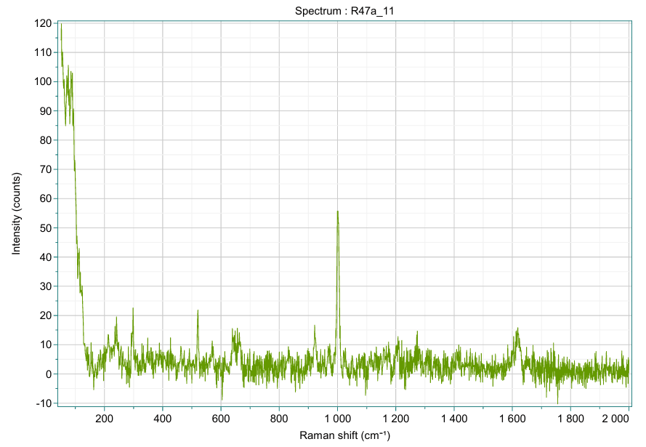

Figure 52

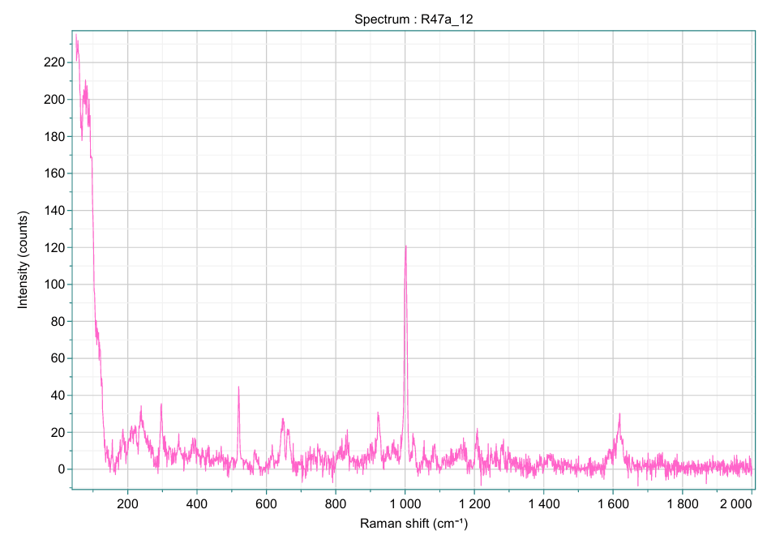

Figure 53

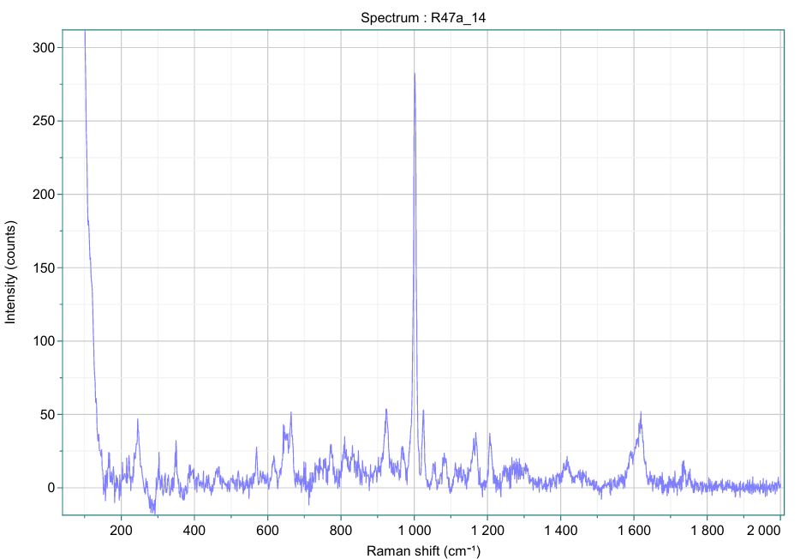

Figure 54

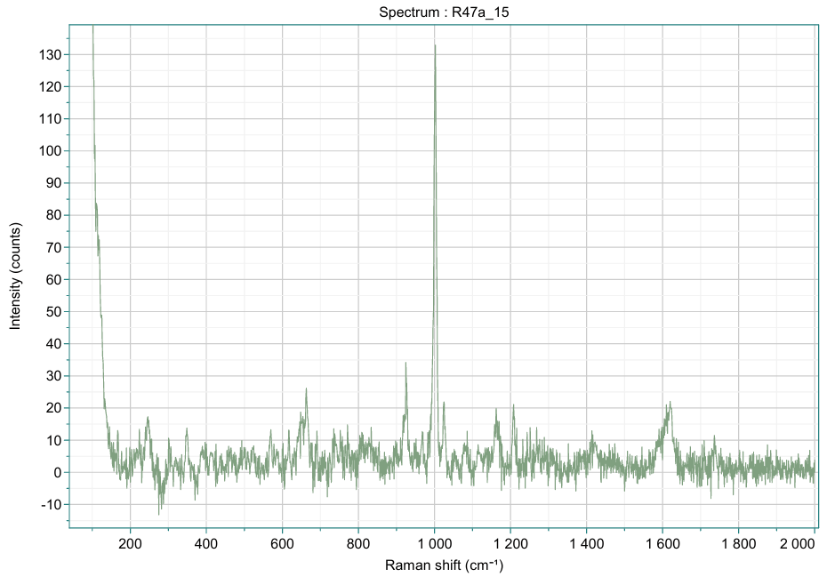

Figure 55

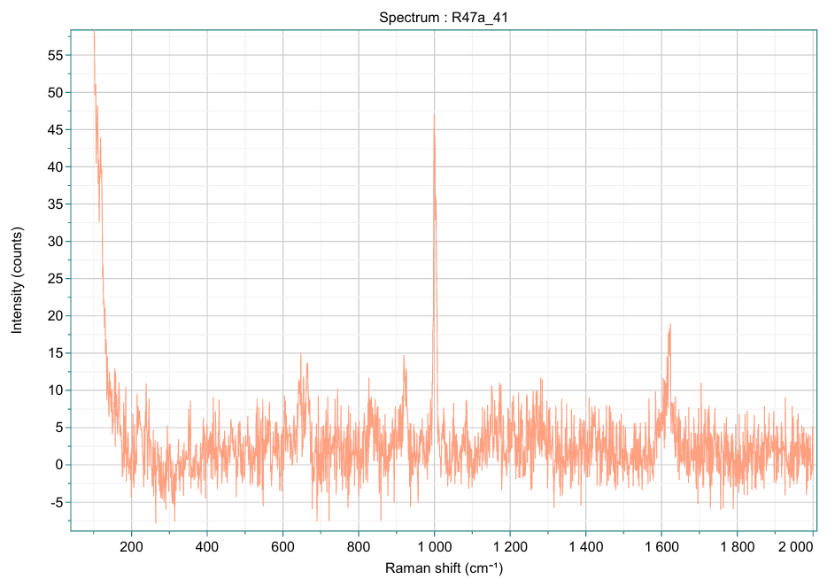

Figure 56

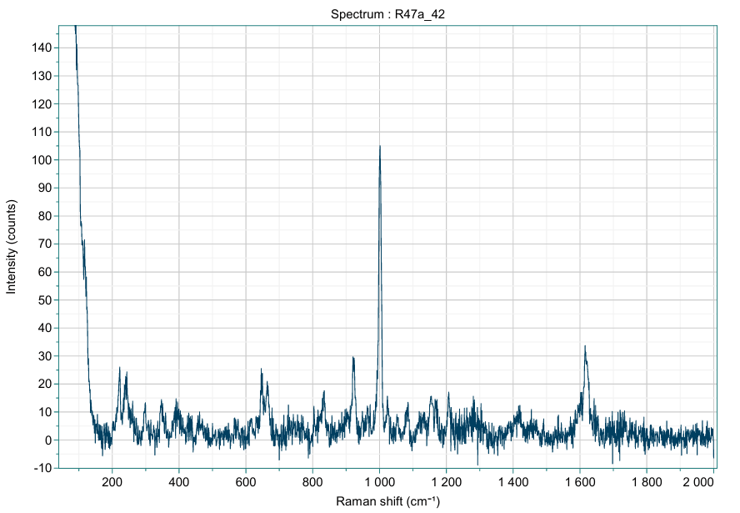

Figure 57

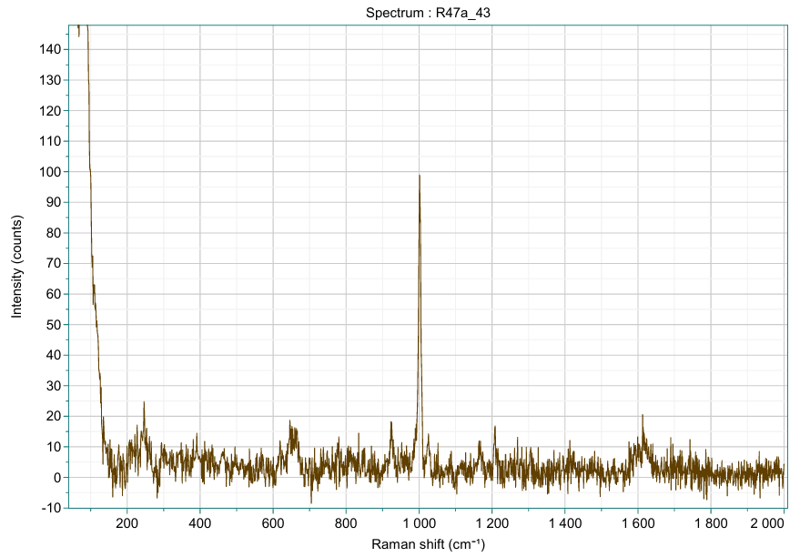

Figure 58

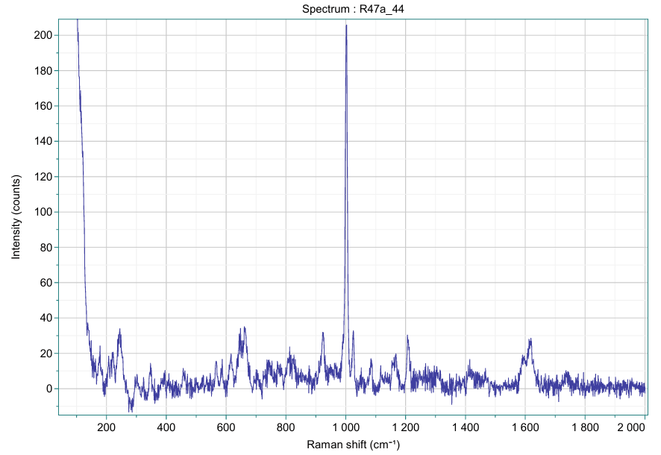

Figure 59

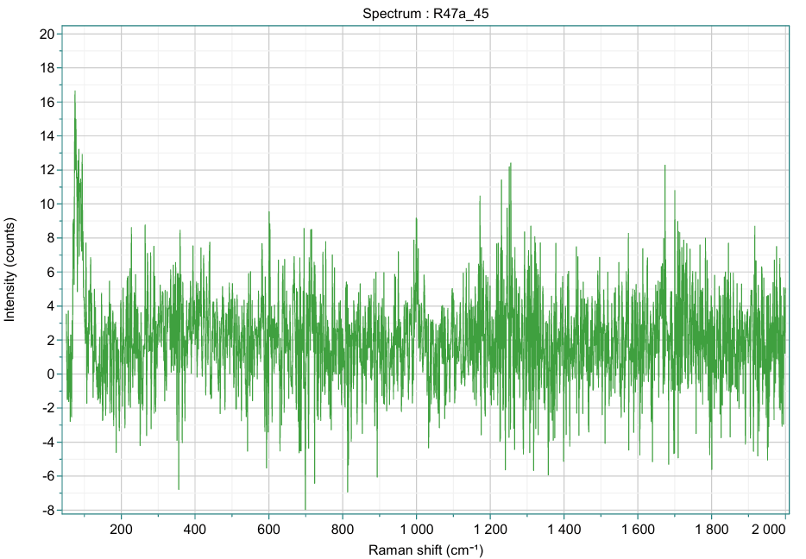

Figure 60

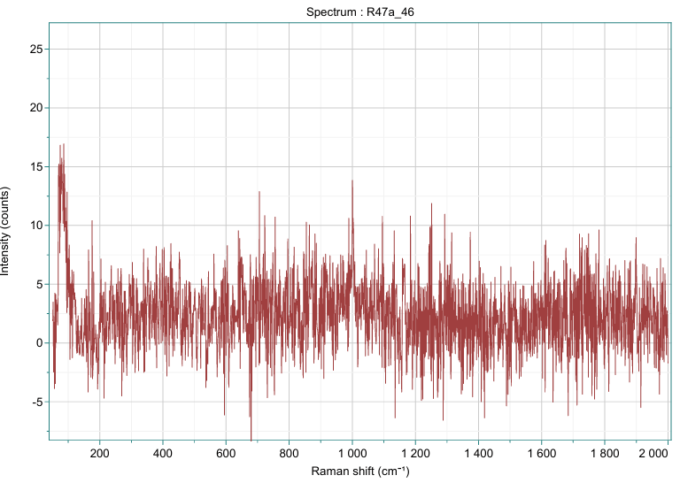

Figure 61

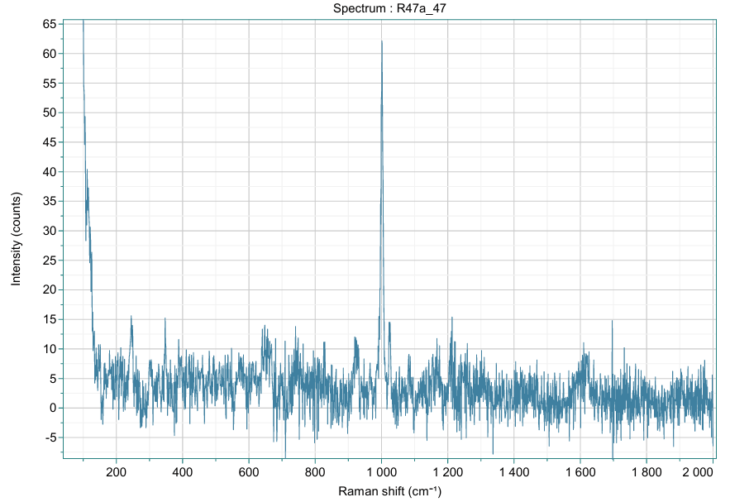

Figure 62

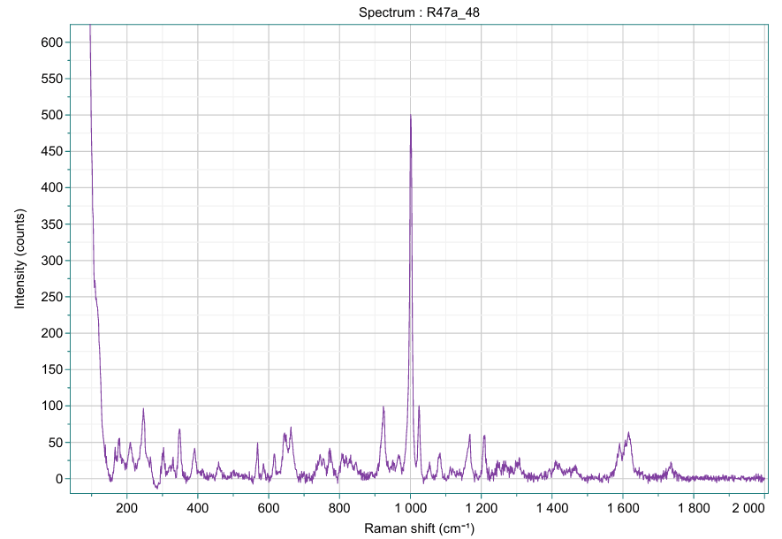

Figure 63

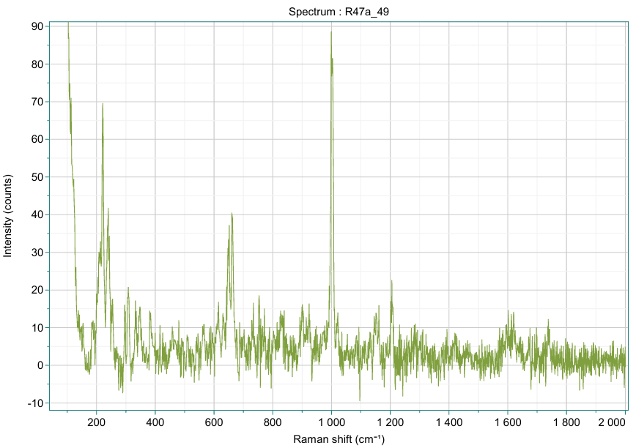

Figure 64

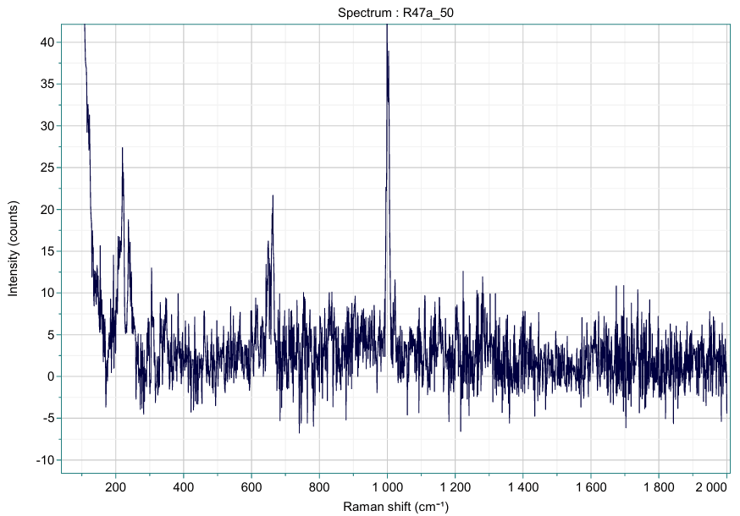

Figure 65

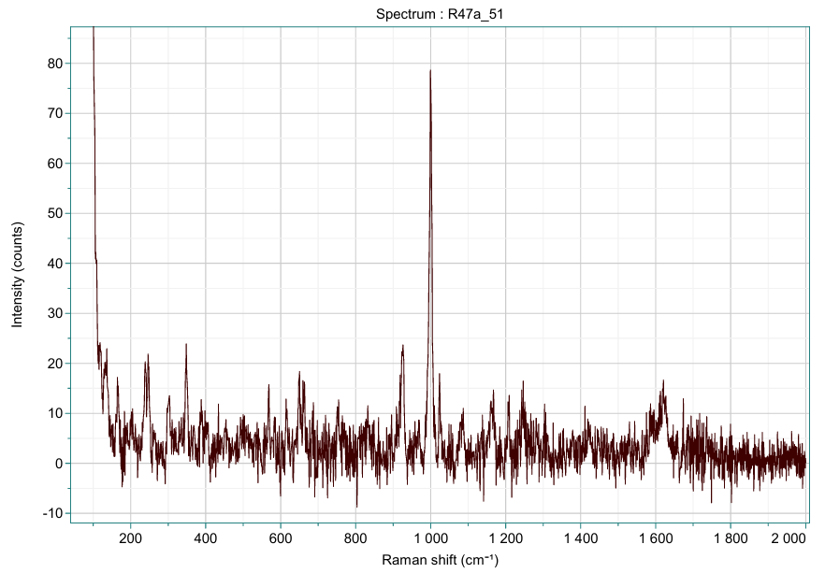

Figure 66

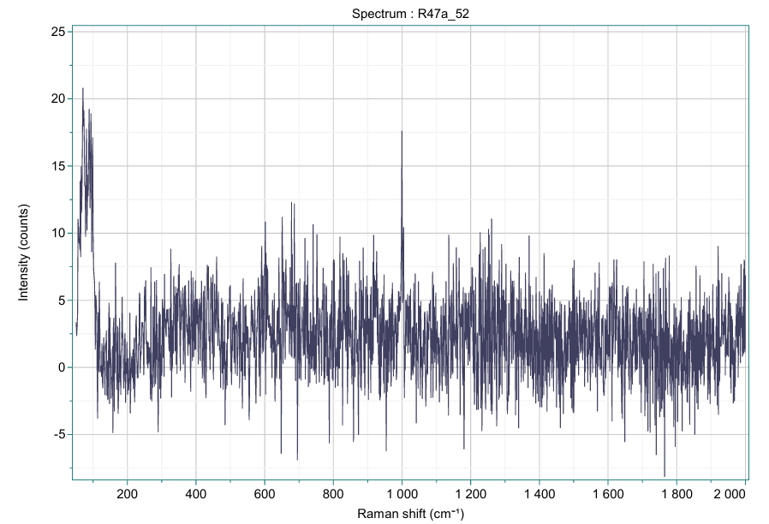

Figure 67

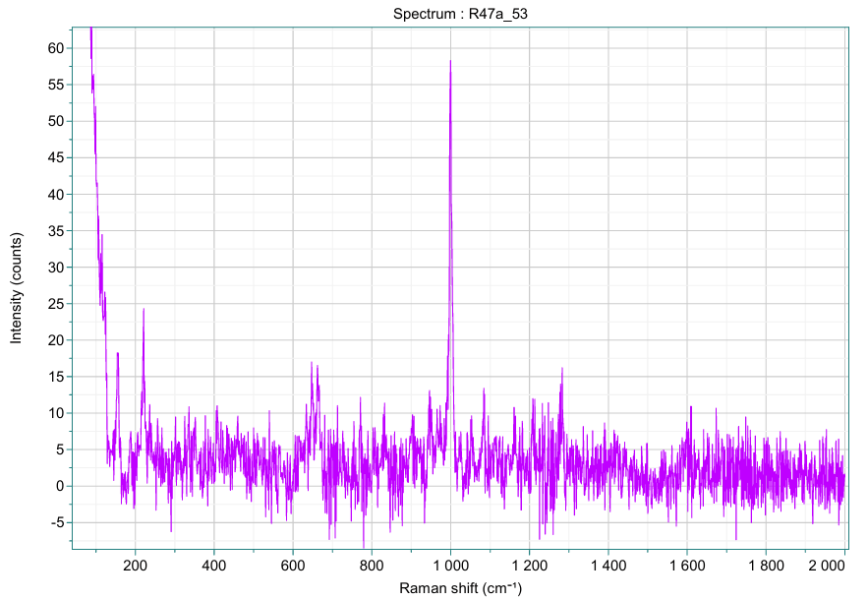

Figure 68

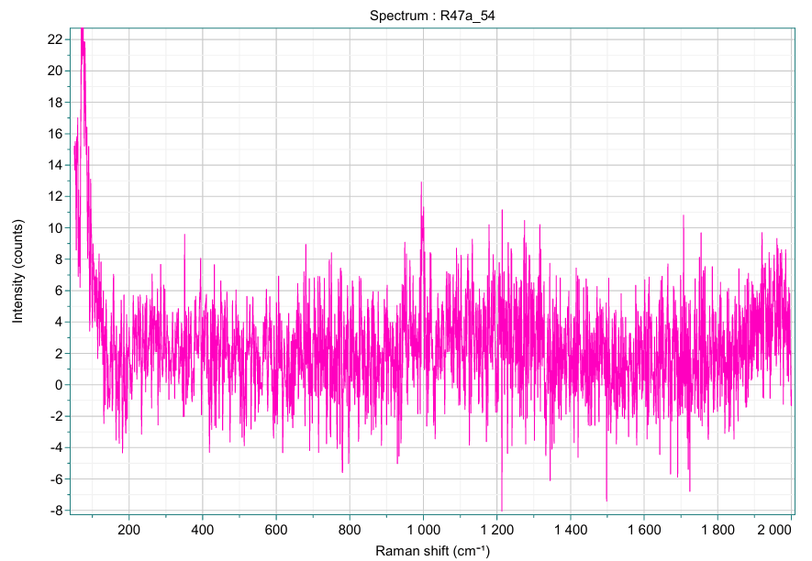

Figure 69

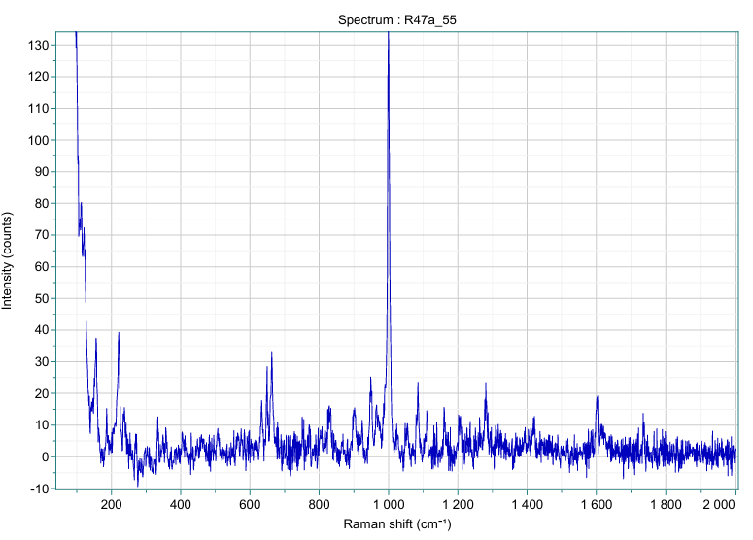

Figure 70

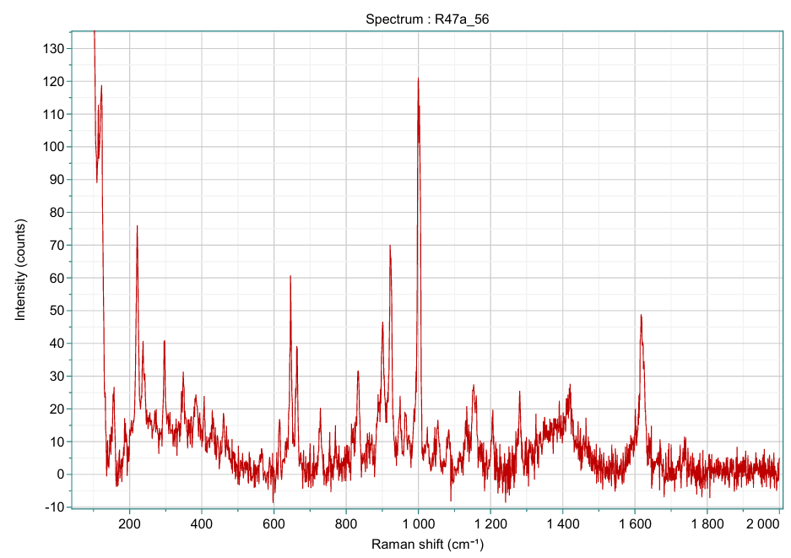

Figure 71

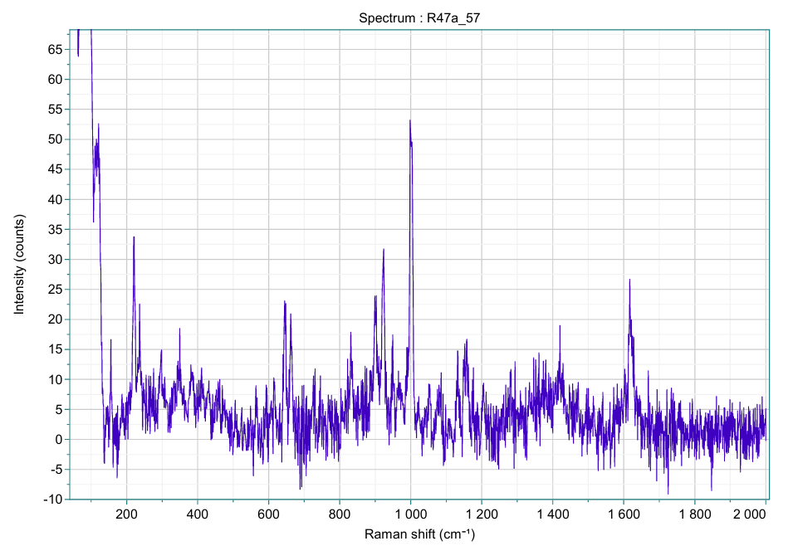

Figure 72

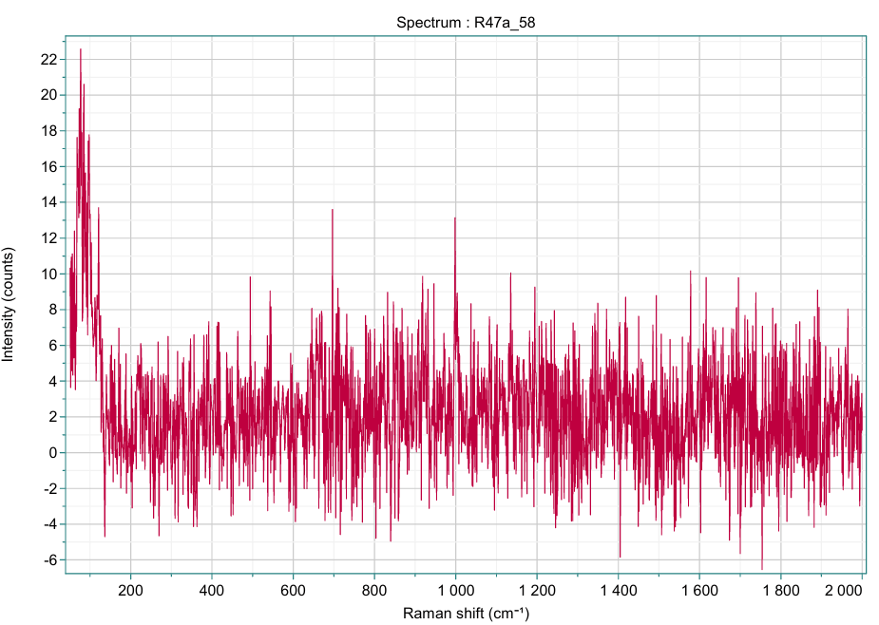

Figure 73

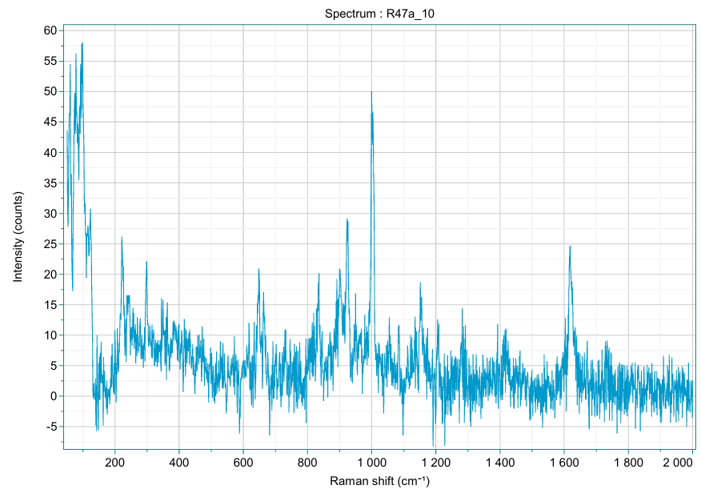

Figure 74

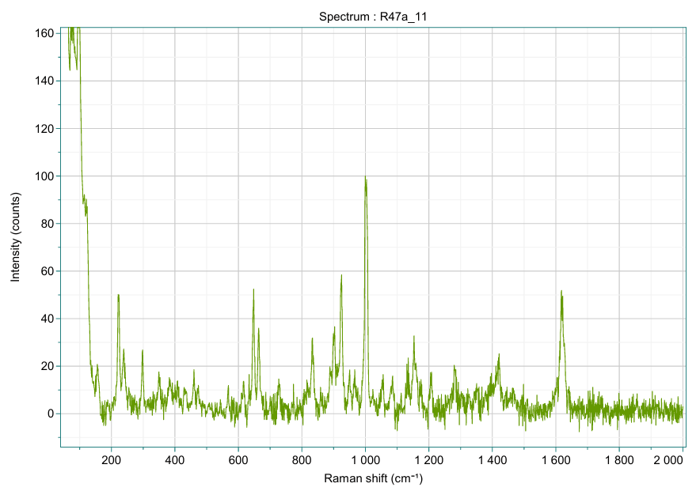

Figure 75

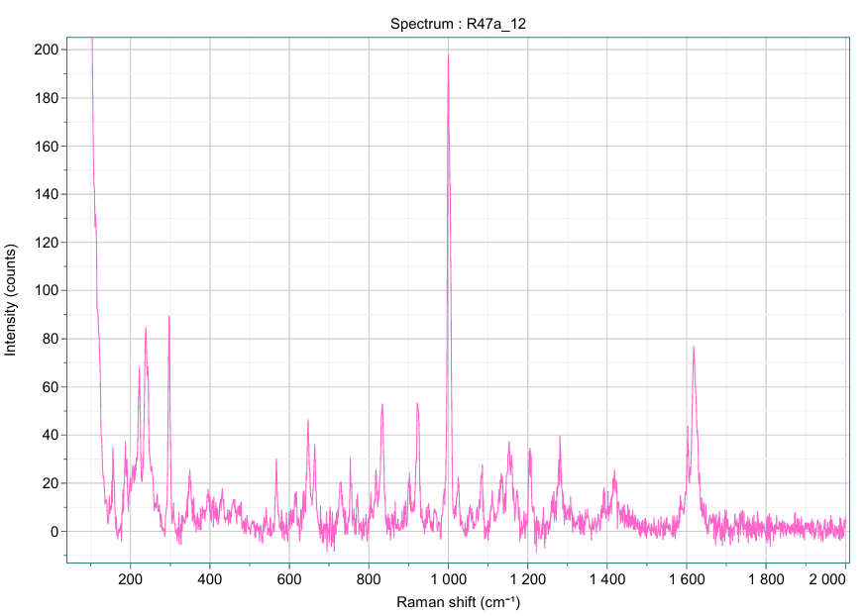

Figure 76

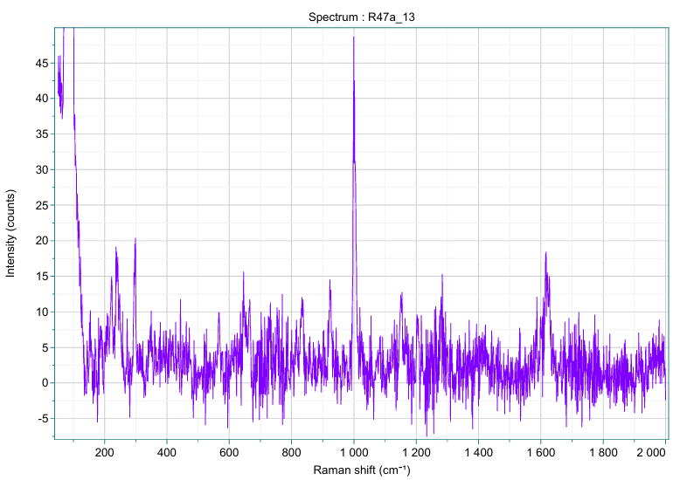

Figure 77

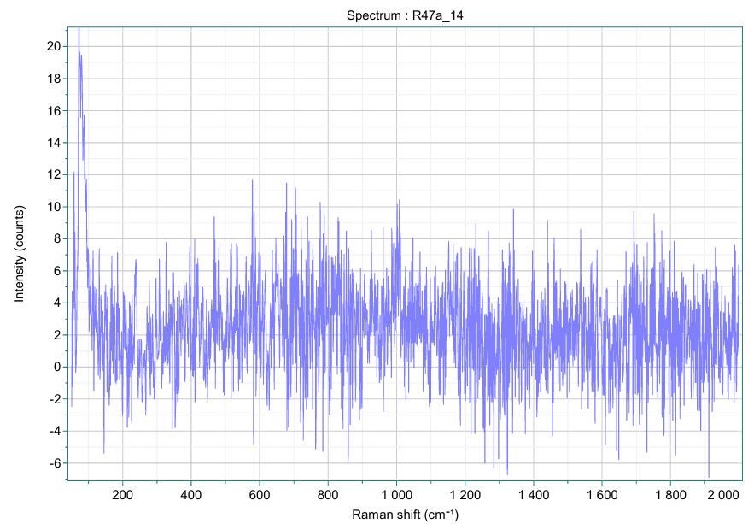

Figure 78

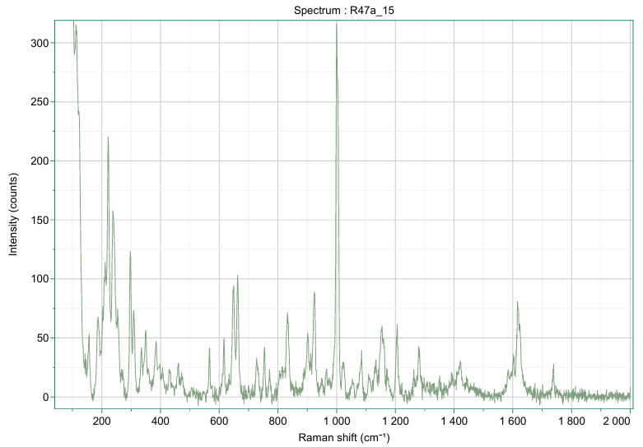

Figure 79

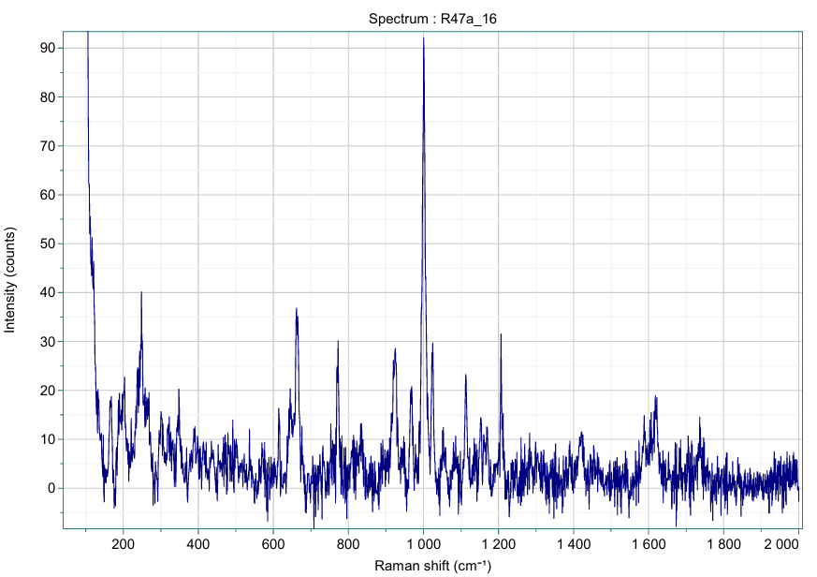

Figure 80

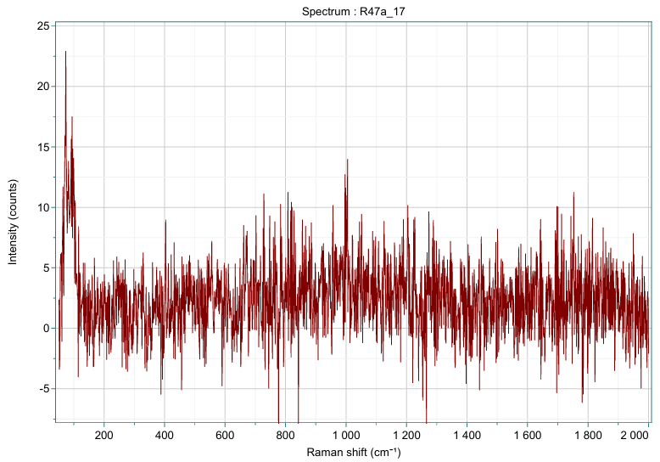

Figure 81

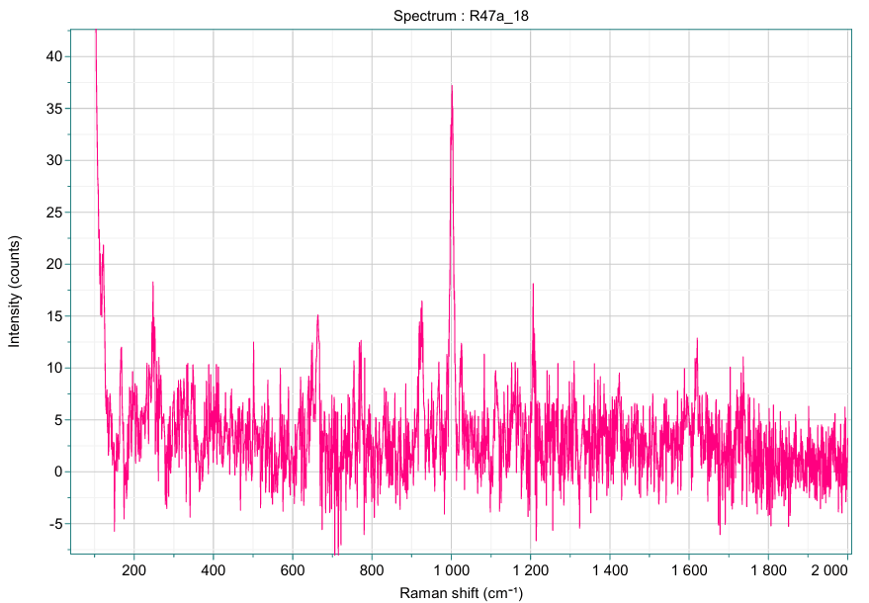

Figure 82

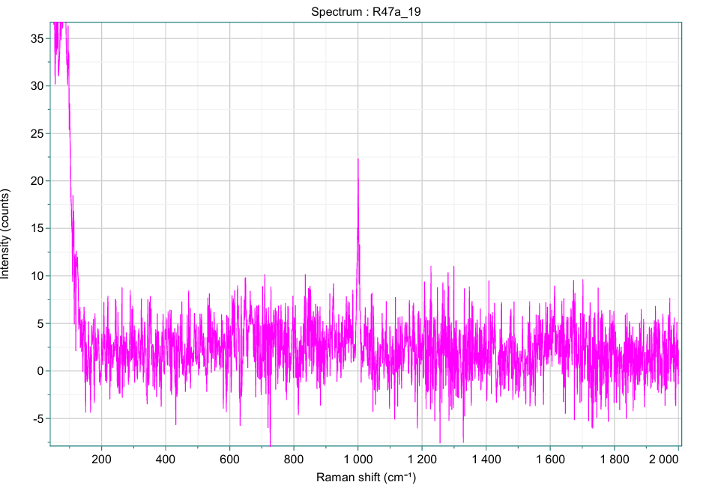

Figure 83

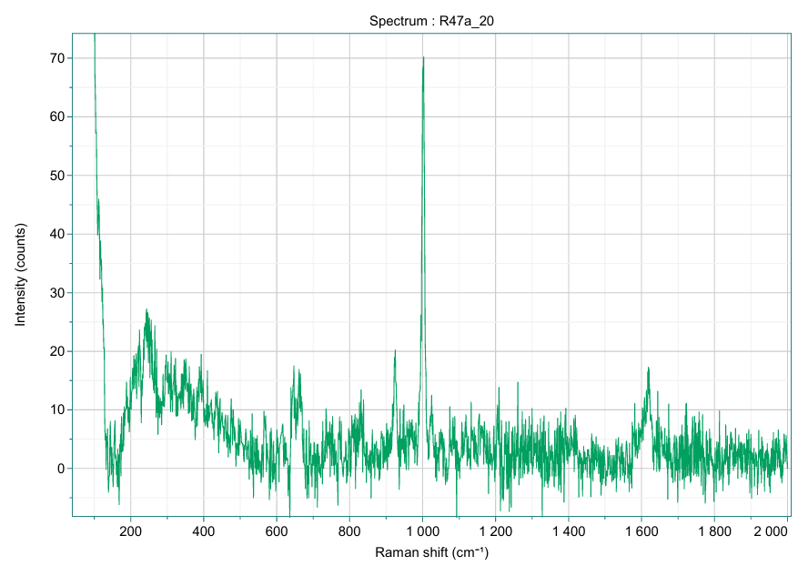

Figure 84

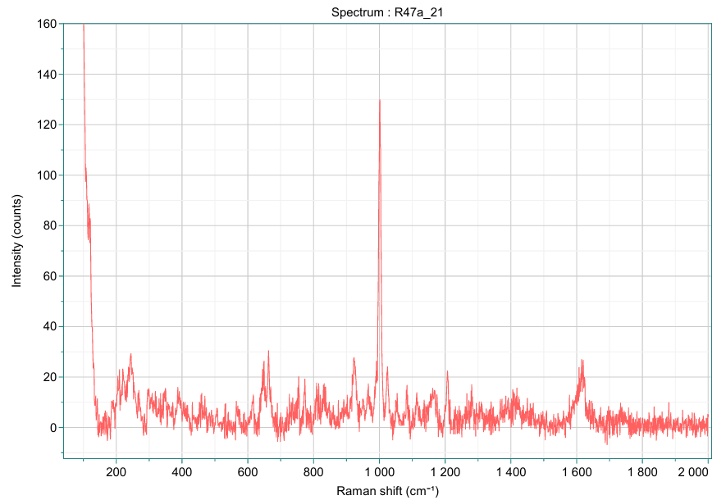

Figure 85

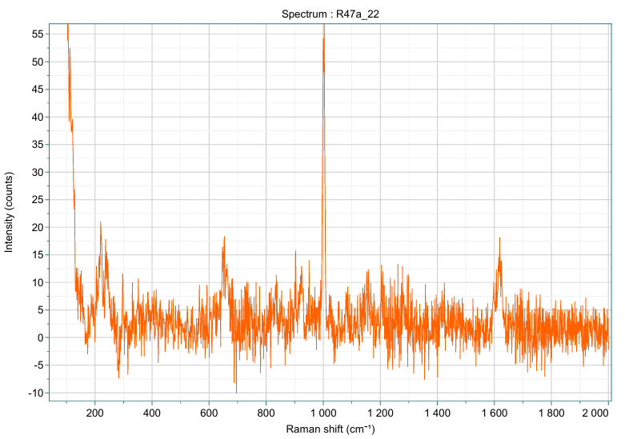

Figure 86

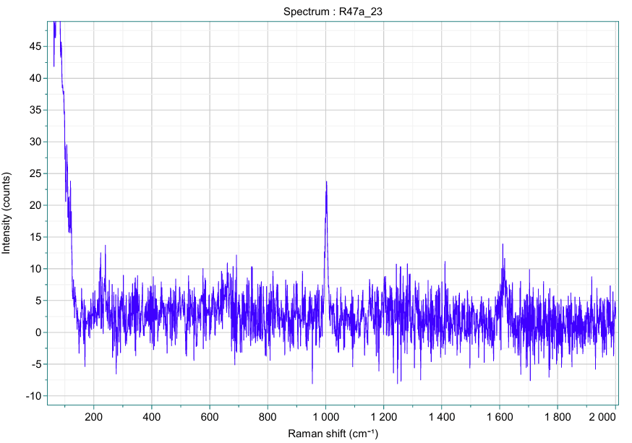

Figure 87

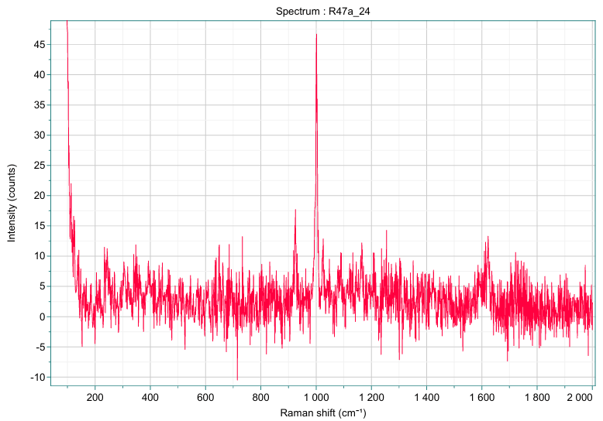

Figure 88

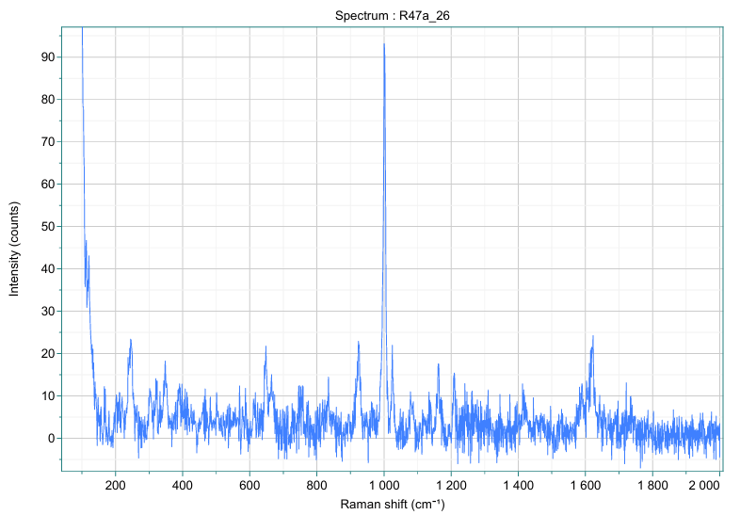

Figure 89

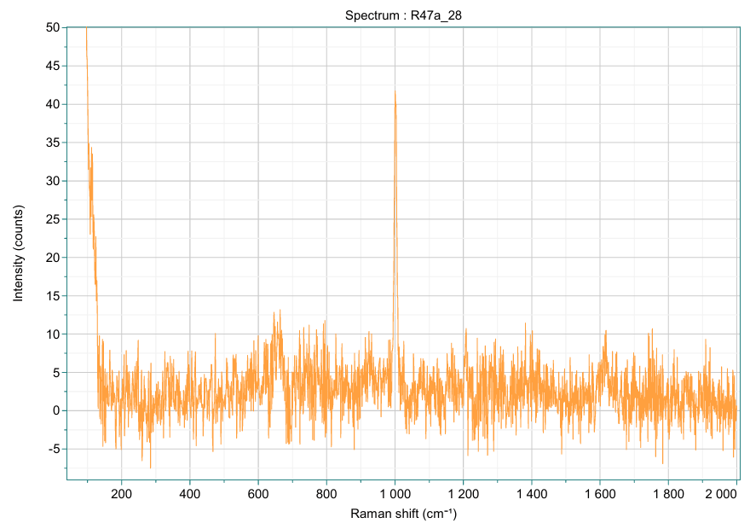

Figure 90

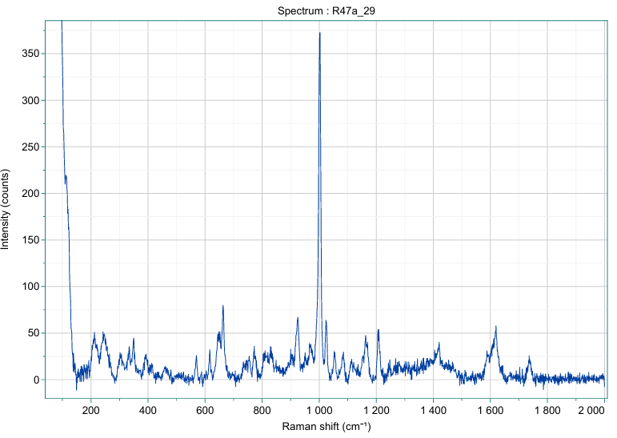

Figure 91

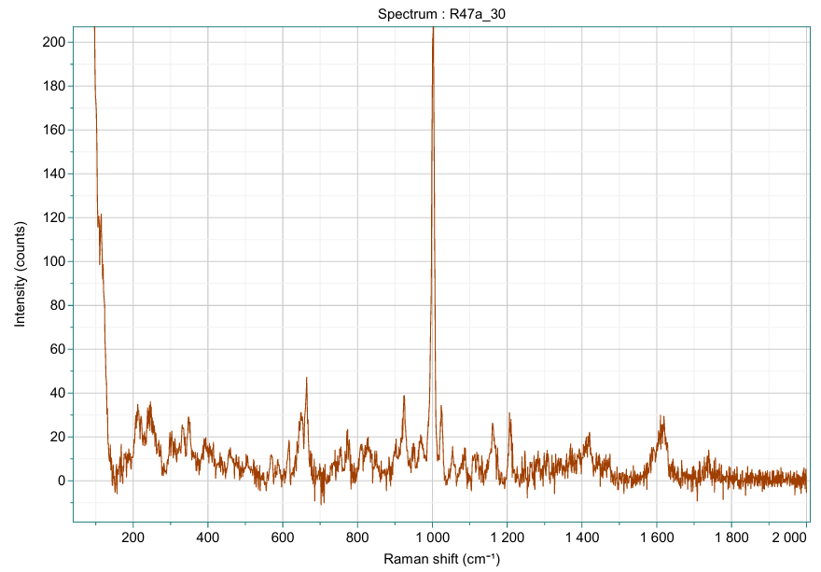

Figure 92

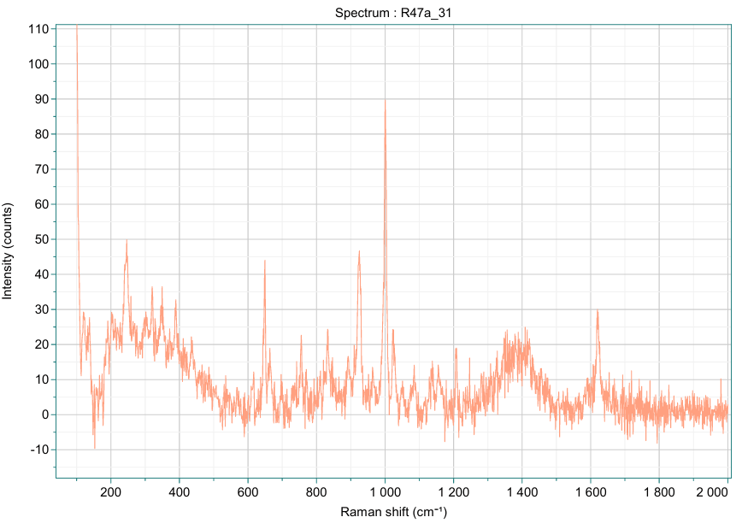

Figure 93

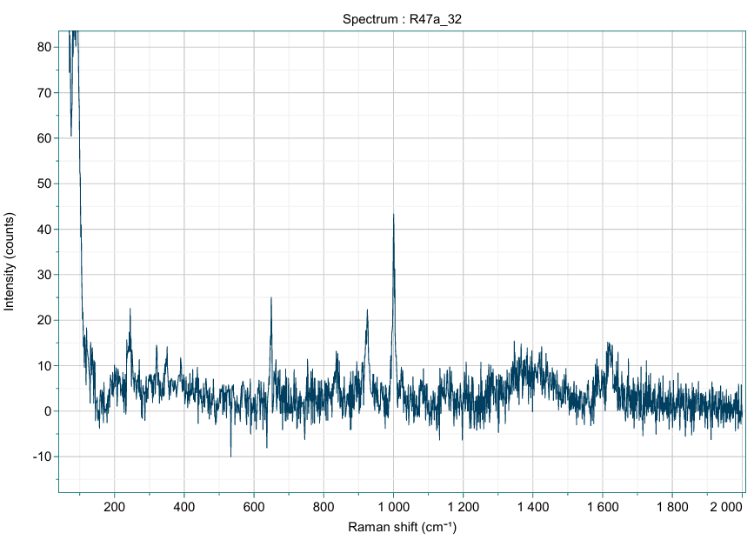

Figure 94

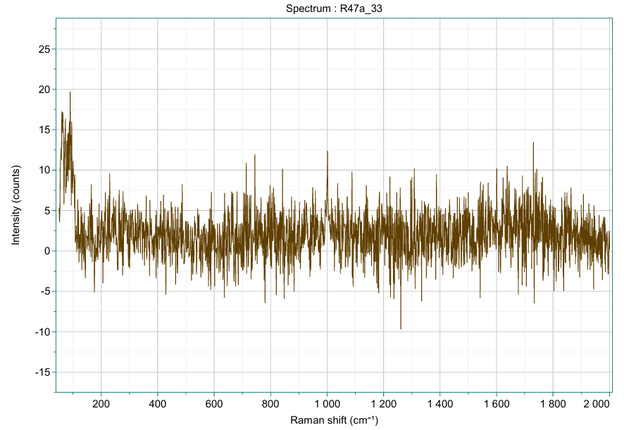

Figure 95

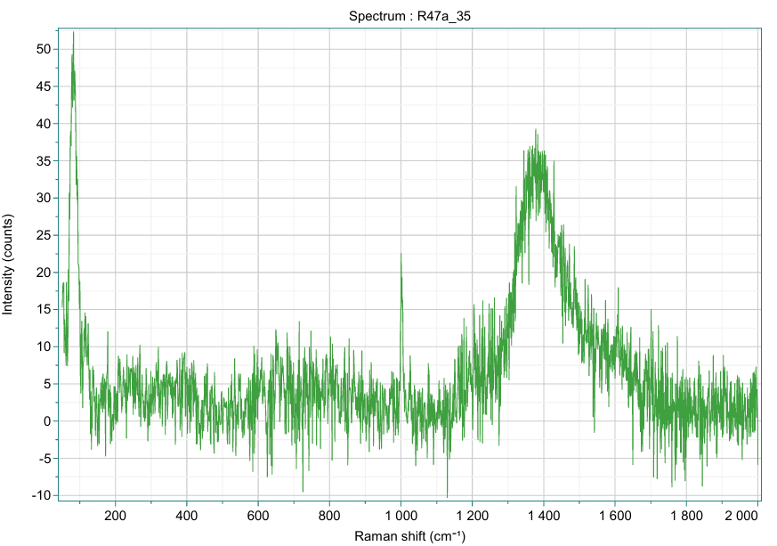

Figure 96

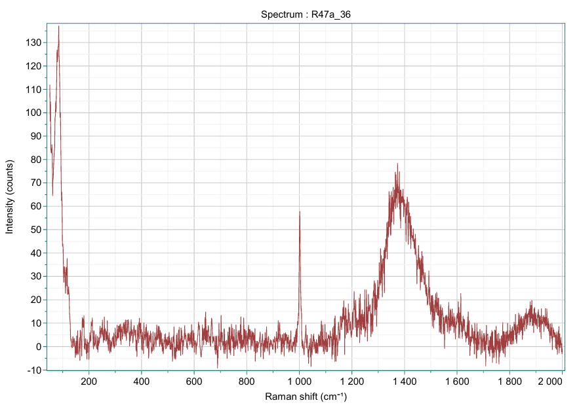

Figure 97

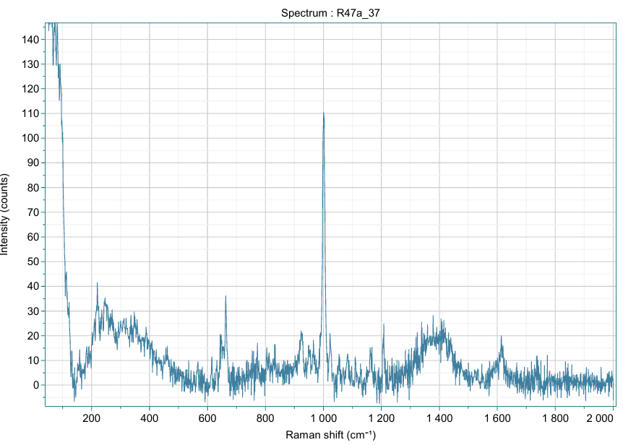

Figure 98

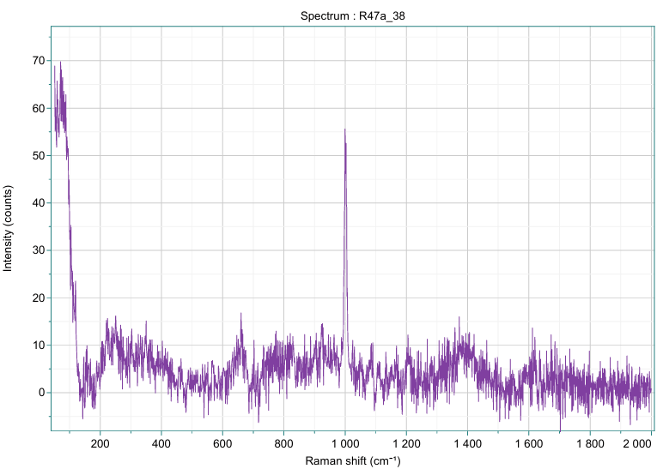

Figure 99

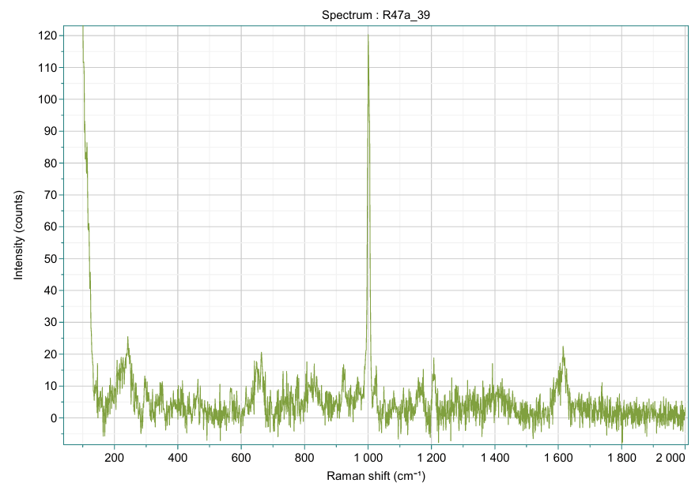

Figure 100

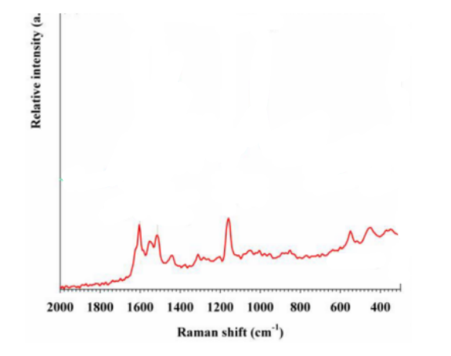

Figure 101: <https://doi.org/10.3390/foods14142543>